**…………..Online Quiz………….**

**Intro and Registration page:**

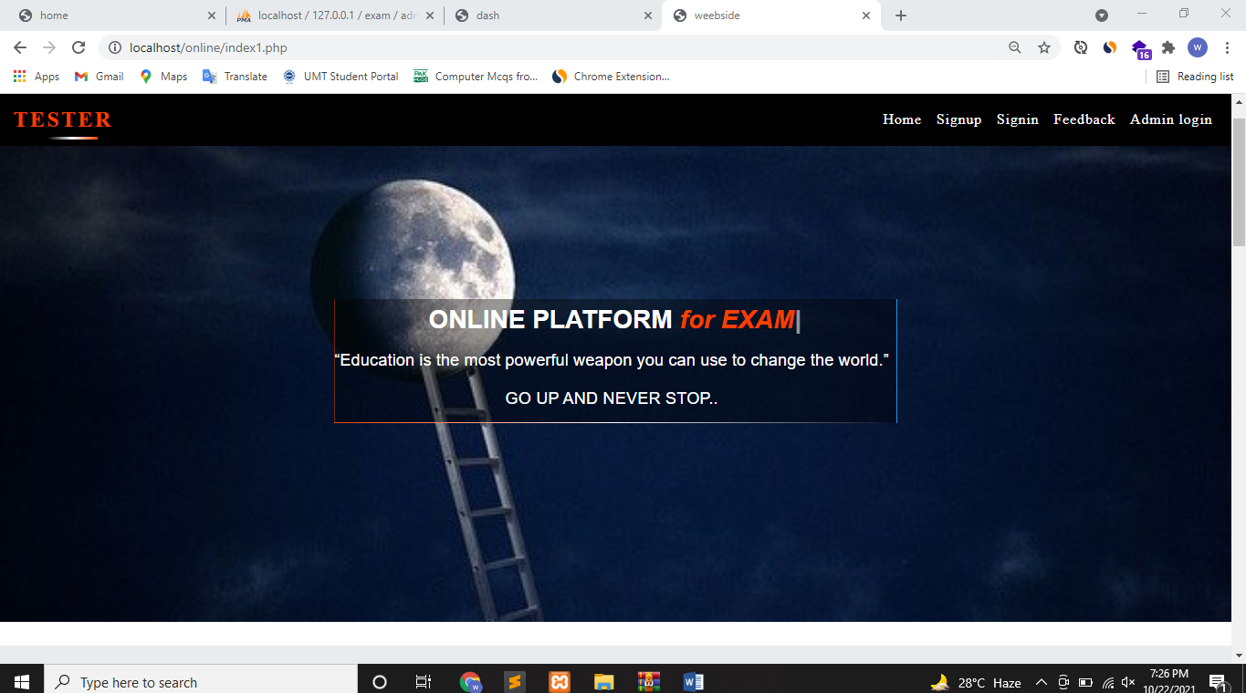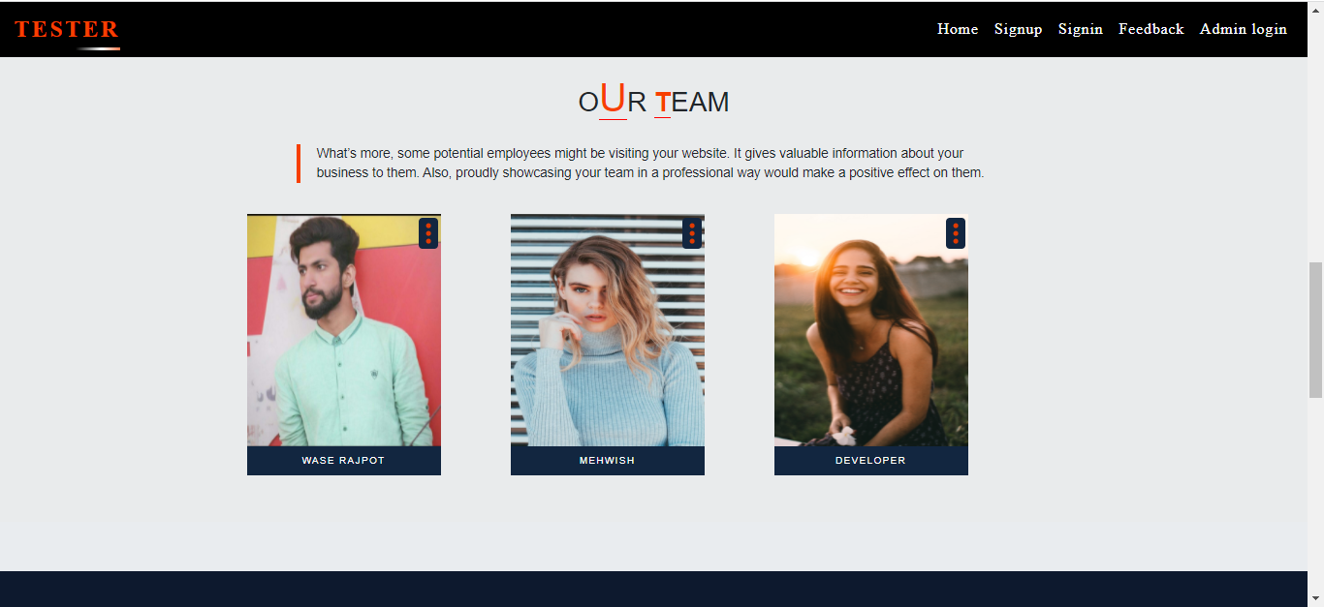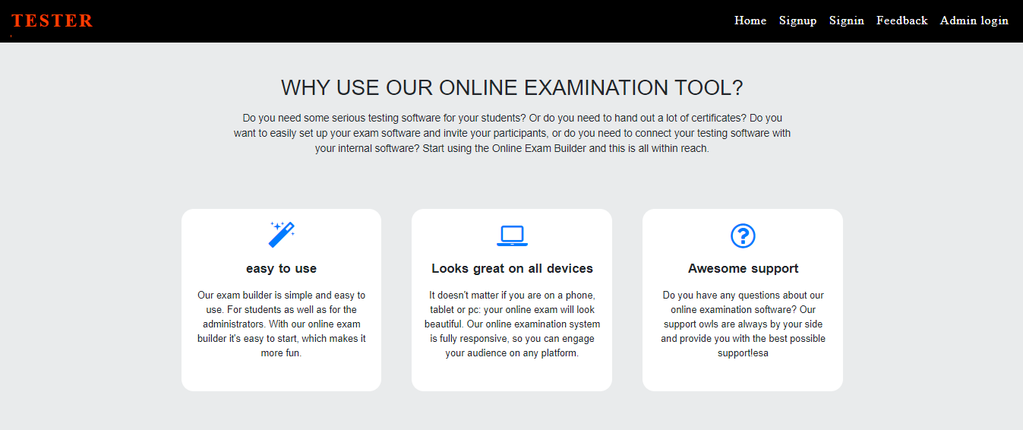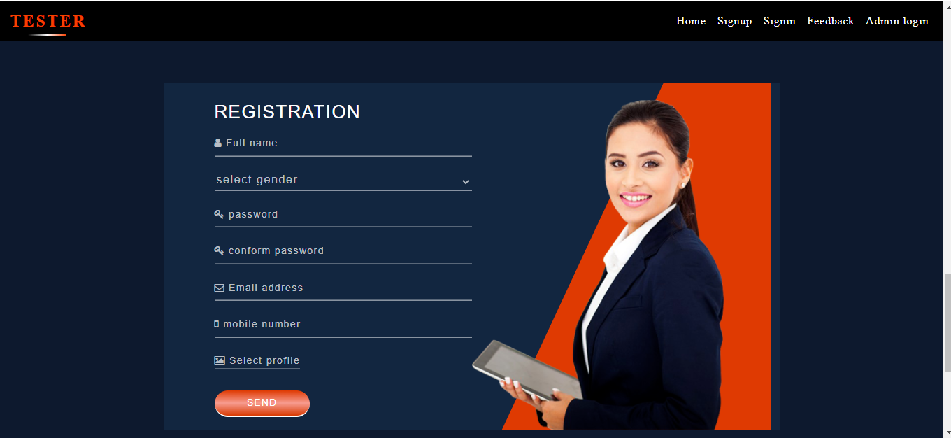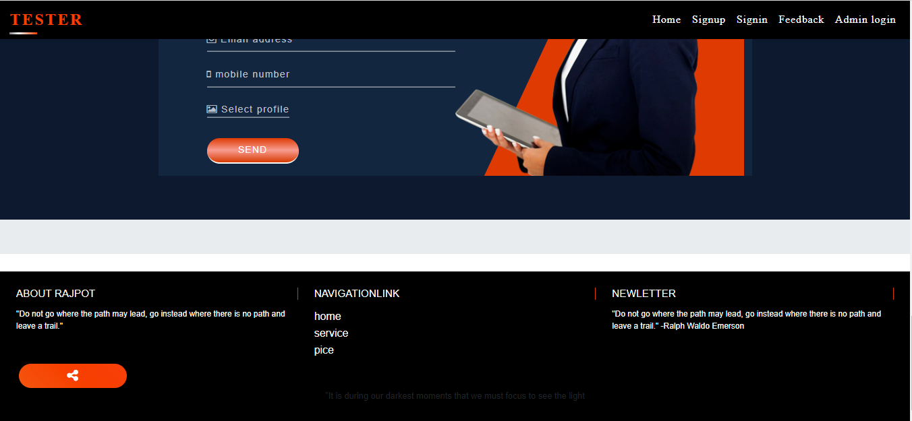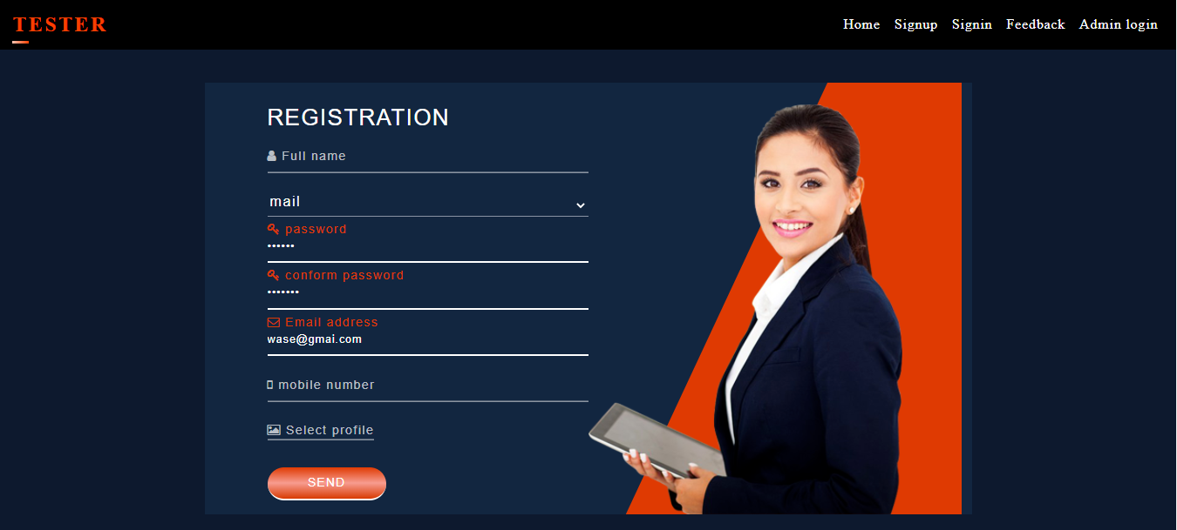

**User login page:**

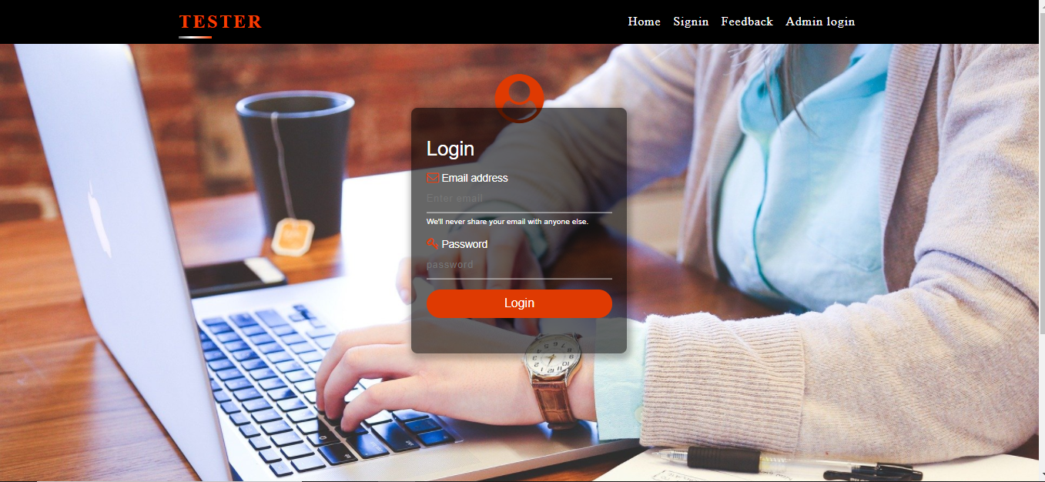

**User deshbord/after user login:**

**User home page:**

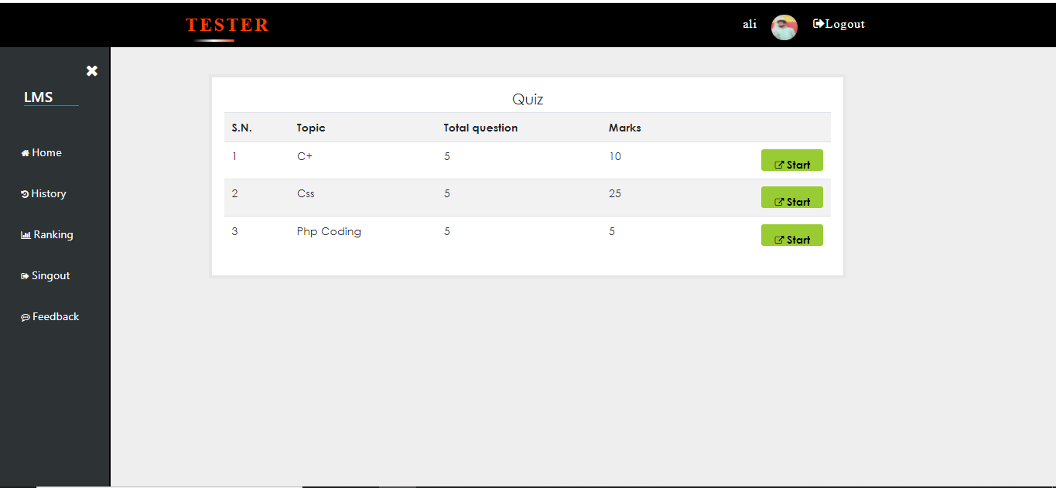

**After attempt the complete quiz result show:**

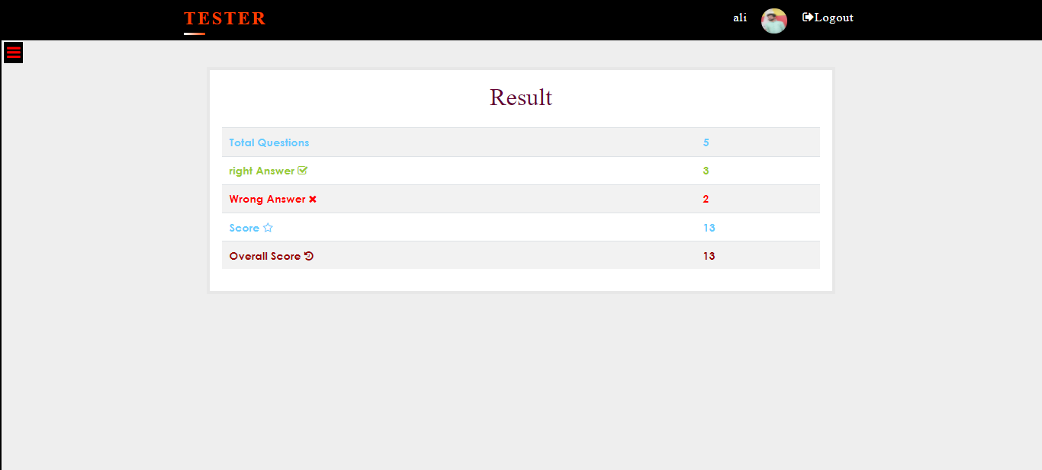

**User History:**

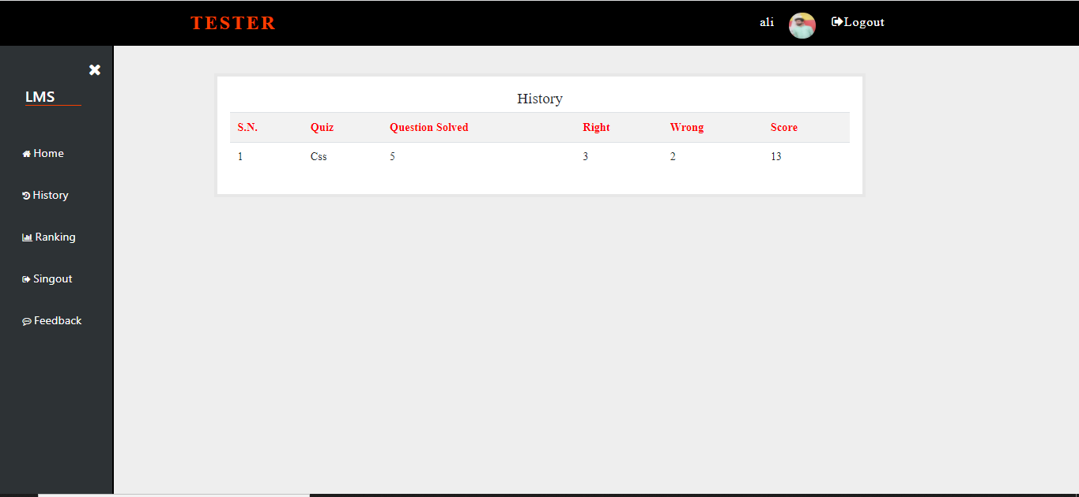

**User Ranking:**

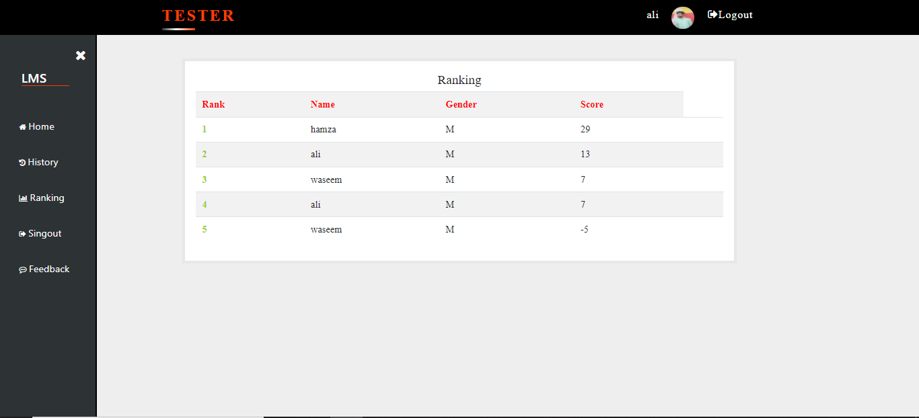

**User feedback:**

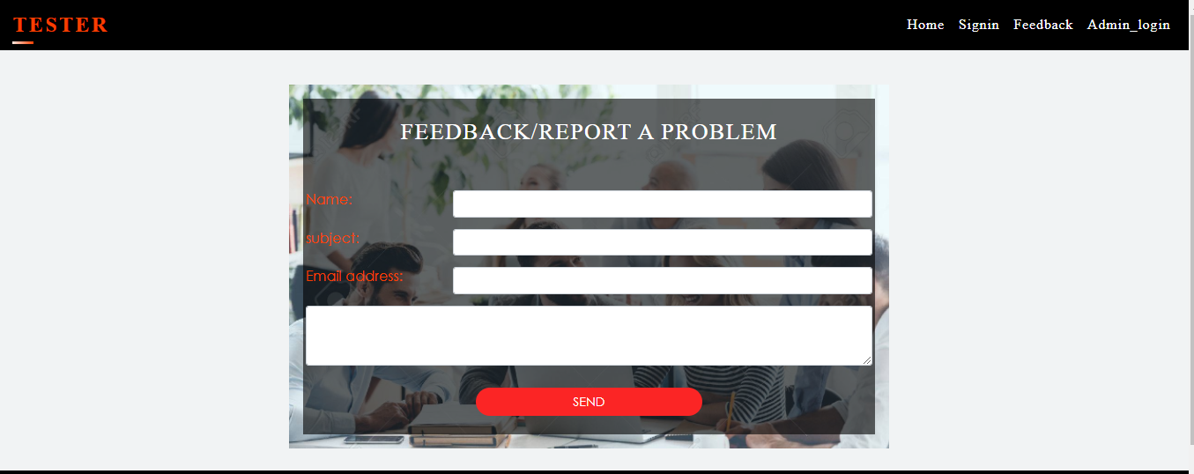

**ADMIN PANEL:**

**Admin login page:**

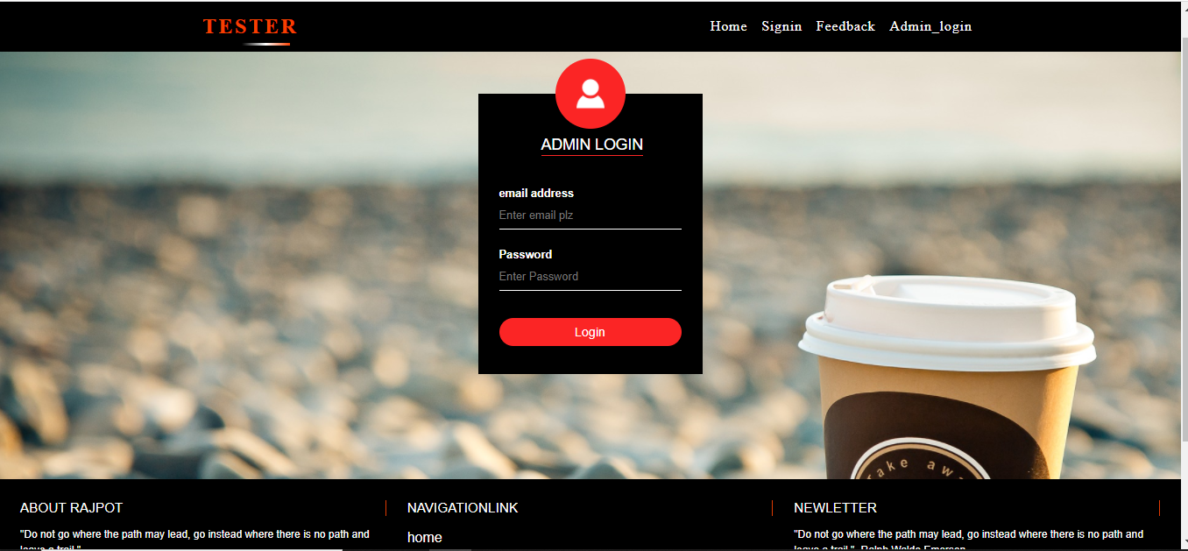

**Admin home page:**

**here is the show the all quiz along subject and marks**

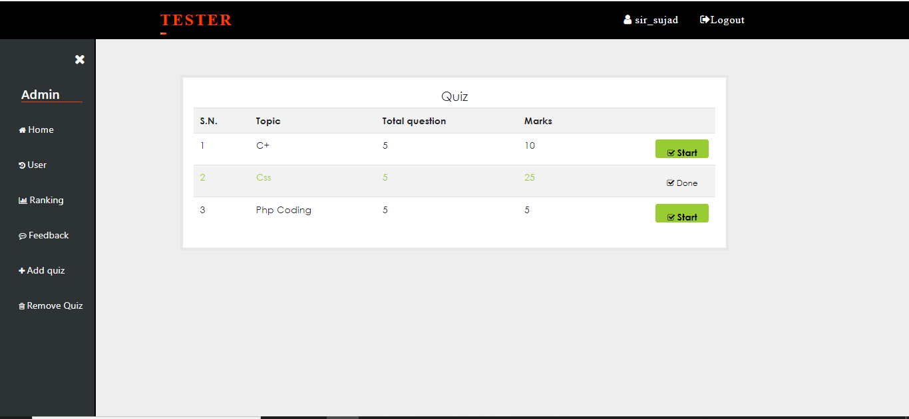

**🡪 admin_user page :**

**In this page show all the user along their record .admin can delete any user………**

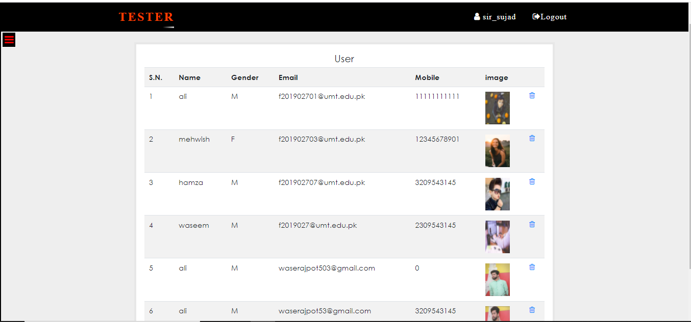

* **Admin _Ranking_page:**

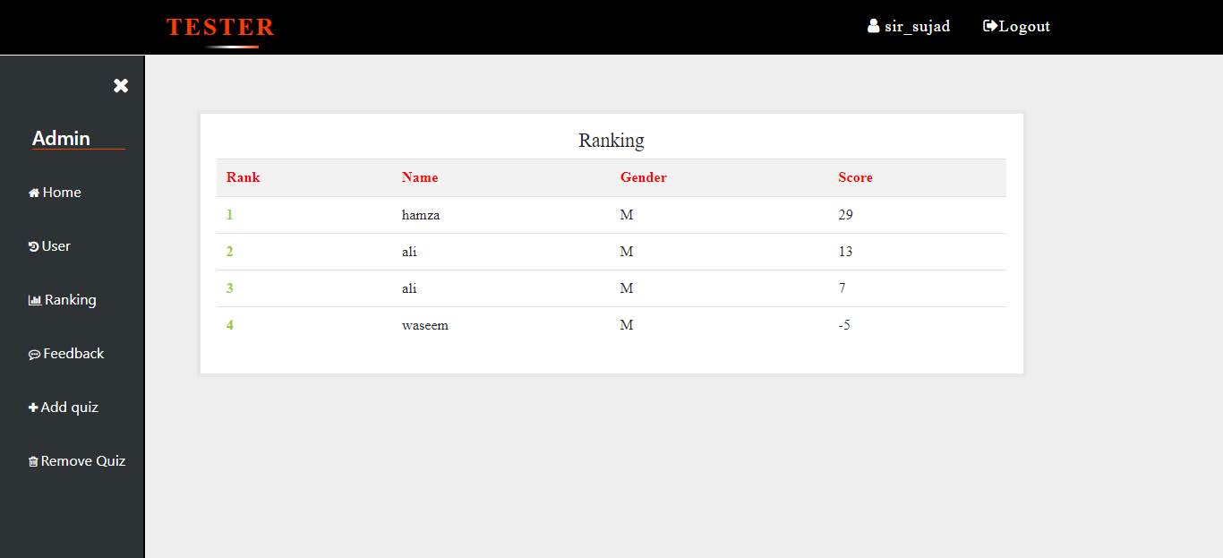

**🡪Admin_feedback page:**

**All feedback show in this page …admin can read and delete any feedback message …**

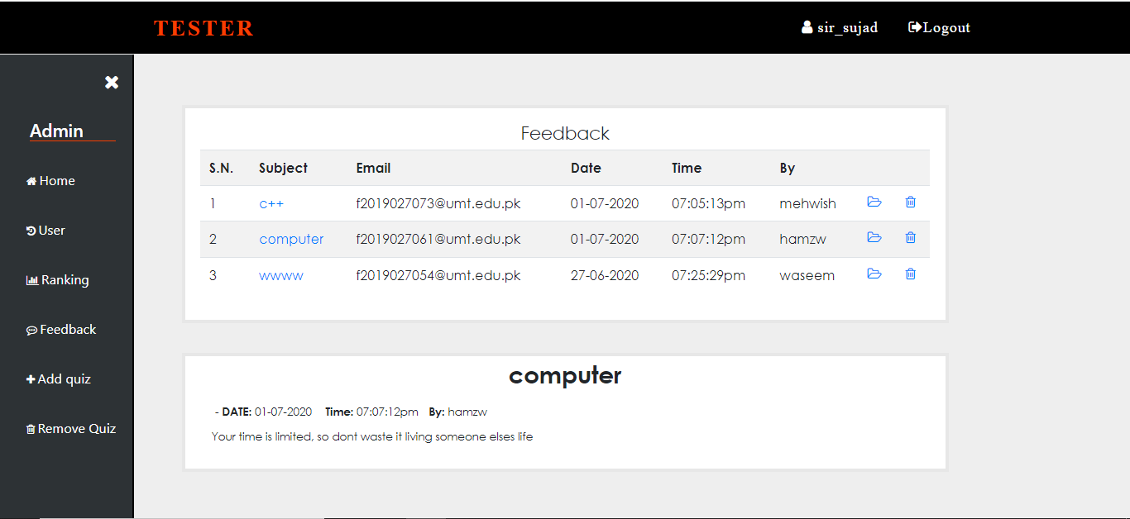

* **Admin_add_Quiz _page:**

**In this portion admin can add the quiz tital ,total number of question,enter the marks of one mcq,and minus mark of wrong question after admin redirect the next page where admin add the question and 4 mcq and also enter the correct option………**

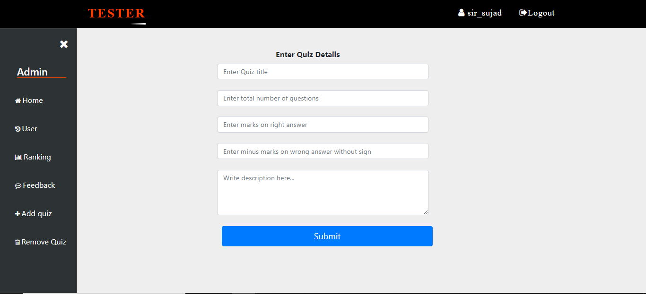

**Second page;**

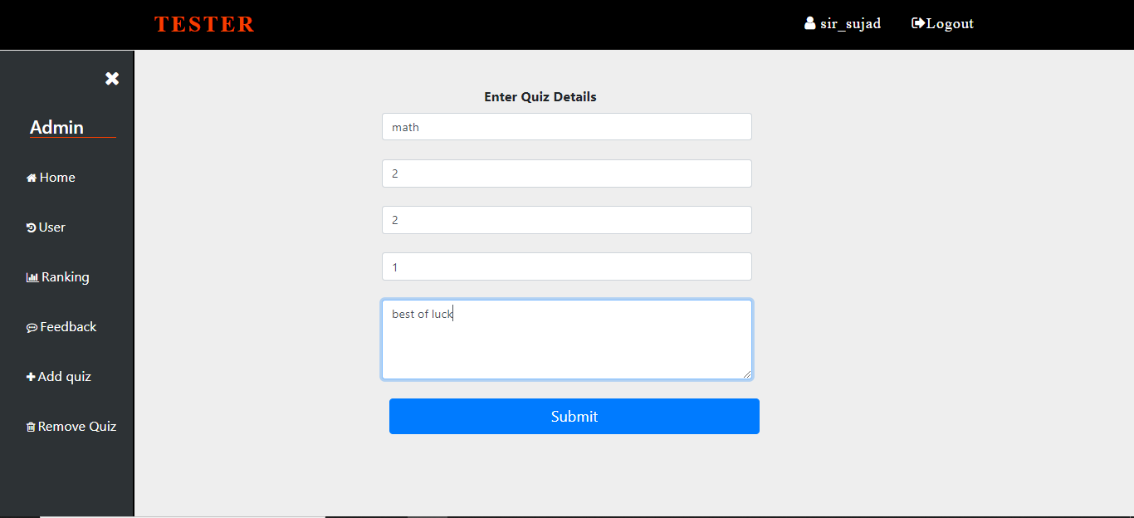

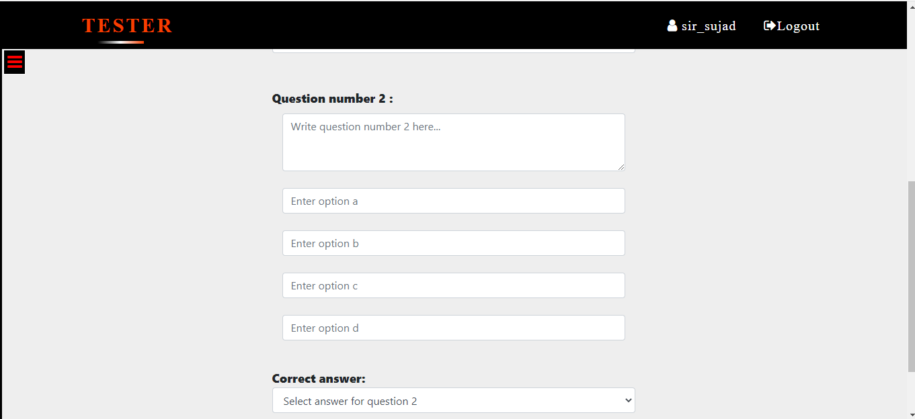

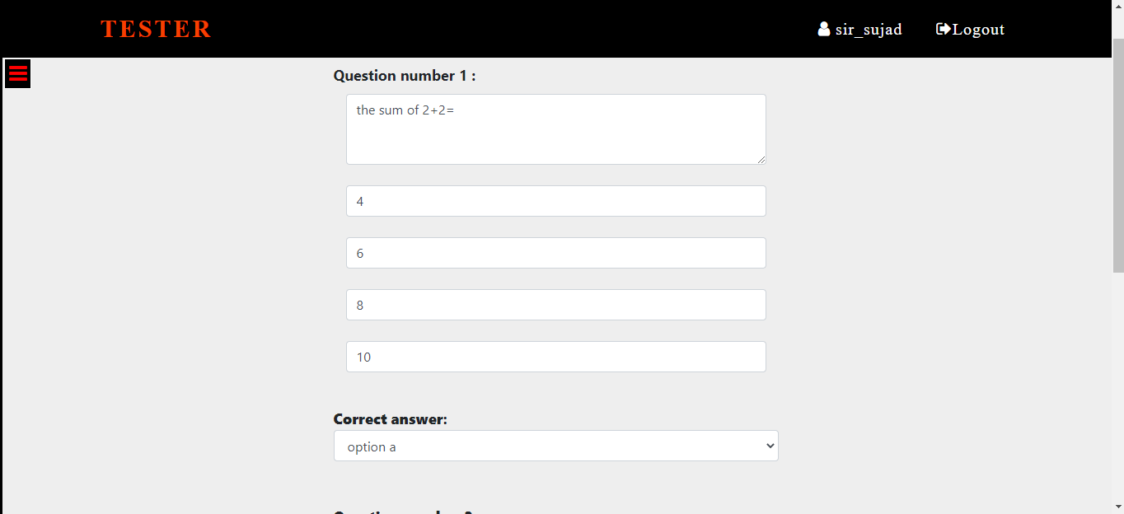

* **Admin_Remove_quiz page:**

